Instructions for 300PAirway Covering Fellow/Moonlighter

Dear Fellow,

The 300P airway algorithm is listed below. You are providing this important departmental service on nights where there is now anesthesia presence in the ICU. The airway algorithm for 300P is listed below, as well as the photograph of the actual pager that you are responsible for carrying, maintaining, and handing off to the next appropriate provider. Your shift begins at 6PM and ends at 7 AM.

You do not have any OR responsibility and you are only responsible for responding to Codes or airway emergencies. You will get pages for all codes occurring hospital wide (800P); though you are responsible for responding to the codes on 300P, you should also check in on codes in 500P in case the 500P team needs backup.

300P Airway Pager 12640 | 300P Airway Algorithm:  Always start from the top (#1) and work your way down until you have found someone who can help you carry the pager!  - MICU 300P GREEN Resident (6a-6p or 6p-6a)  - Periop Resident/Attending (7a-5p)  - Periop Team Huddles with Code Team in E2 Nurse Station at 7:30 AM  - 300P Scheduler/300P OR (5p-6p)  - Highest call number attending with a resident (5p-7p) - call the 300P scheduling phone to hand off the pager  - Moonlighting Fellow (6p-7a)  - Acute pain resident when moonlighting fellow not available (6p-7a on weekdays, 5p-7a on weekends)
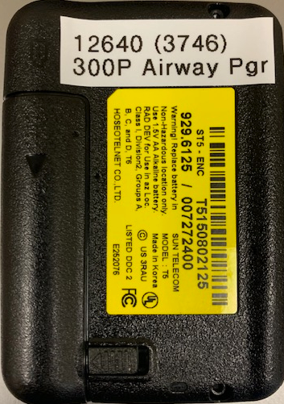

The link to the 300P Airway Schedule is also listed below:

https://docs.google.com/spreadsheets/d/11heW0k5CM6NRNBEaRQC9OVedG12SWMbOoDnqHMqVWm0/edit?usp=sharing

You can refer to this link to figure out who you will be handing off the pager to at 7 AM. This is usually an Anesthesia ICU resident in E2. You are able to use one of the call rooms in E2 for these shifts. Look for the call room designated “300P Airway” right in front of room E239 in the E2 ICU. Here is a picture of the door (HE241):

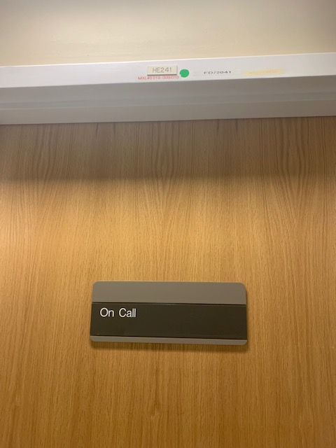

There is an airway bag filled with ETTs, Oral/Nasal Airways that is kept in the E2 work area (see pictures below, this is about 10-15 yds from the call room). You can grab this bag and take it to codes/airway emergencies. I encourage that the first time you take this shift you open the bag and familiarize yourself with the contents. If you open the bag and use any of the inventoried items you can drop the bag off in the 300P or 500P anesthesia work room and grab a new one that’s fully stocked. This is your responsibility. This bag should always be ready to go and fully stocked in the E2 work area.

Thank you again for your help. Do not hesitate to contact me with any questions via email or cell phone : javierl@stanford.edu or 650-704-2825

Javier Lorenzo, M.D.
Clinical Assistant Professor

